- Scatterplot (Sales vs Month index)
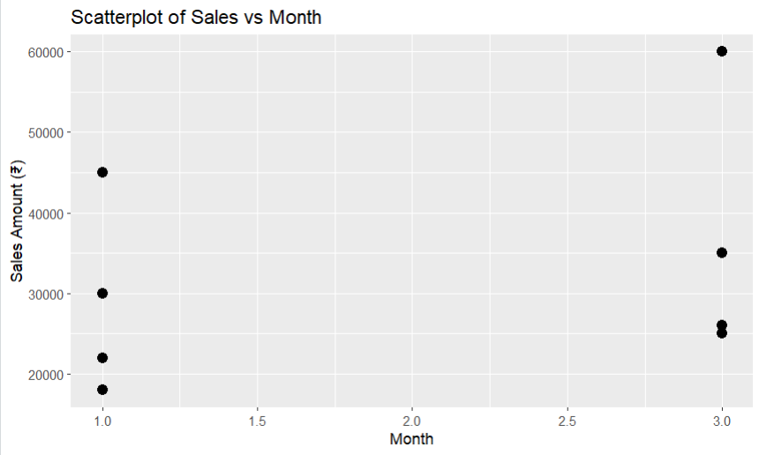
2.Bubble Chart (size = Sales)
- 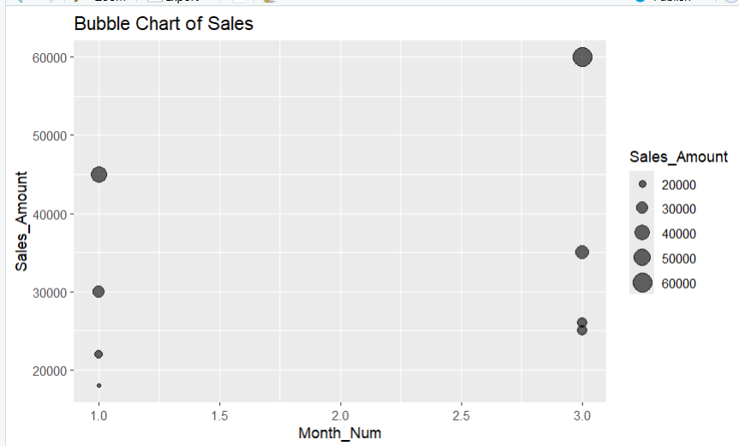

3.Hexbin Plot (density)
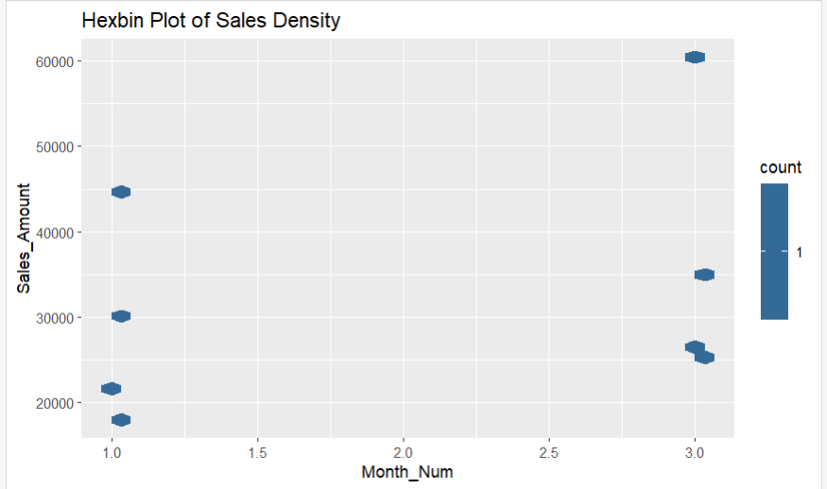

4.Correlogram (correlation)
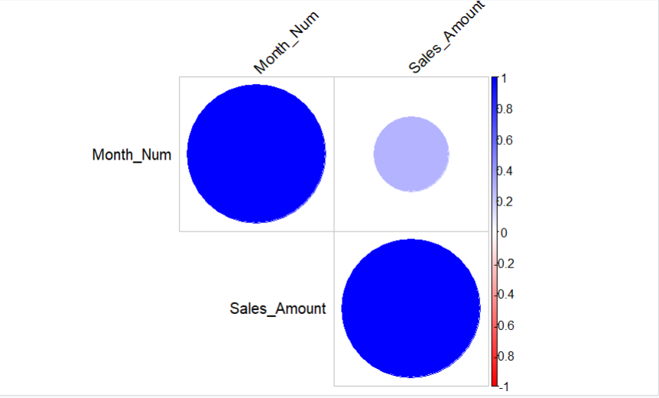

5. Network Graph (Category → Month)
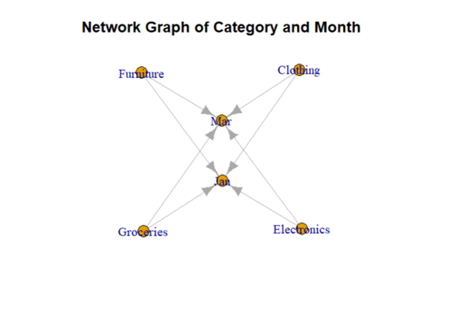
6. PCA (Dimensionality Reduction)
